Main agenda-To create an API to respond with the remaining principle amount when EMI is made

To do this we need a data type with Details and records

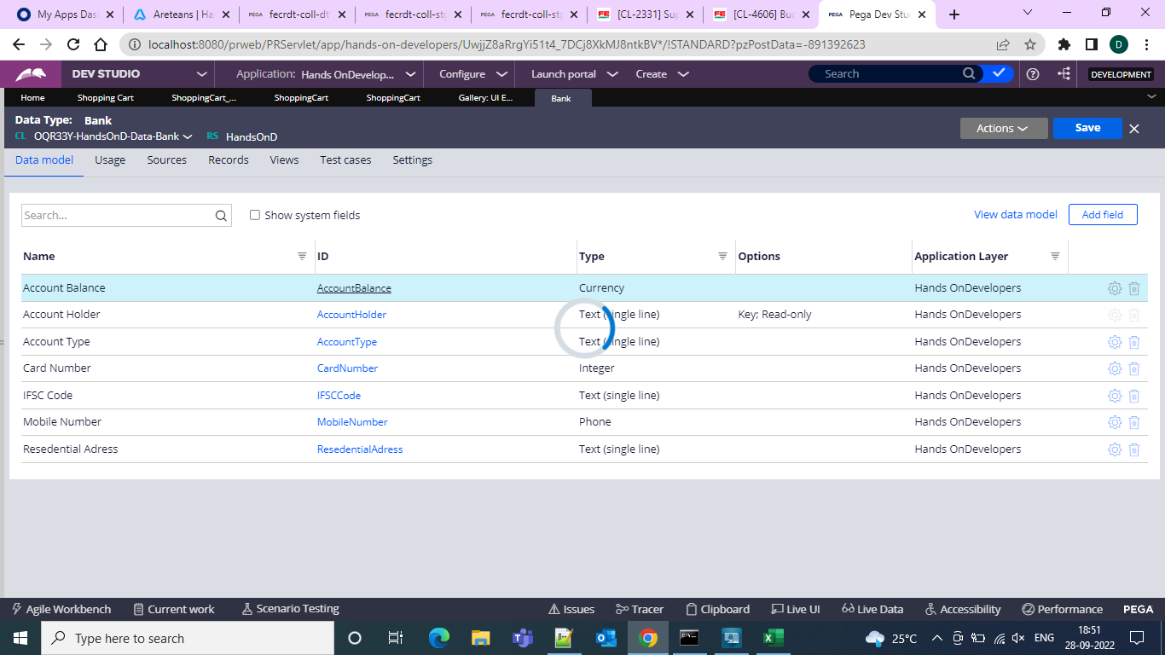

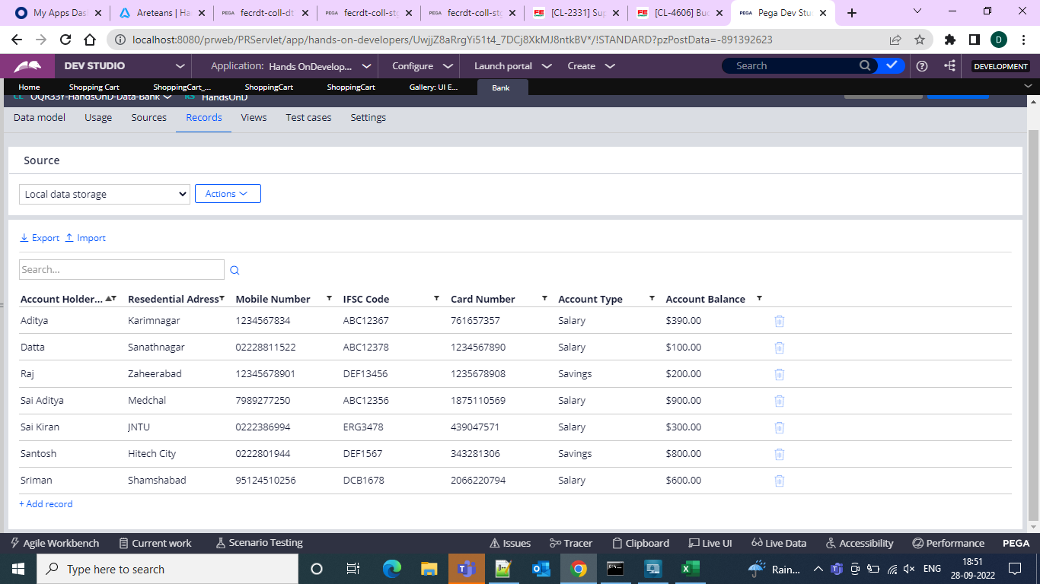

Then we need to create a Service REST Configuration

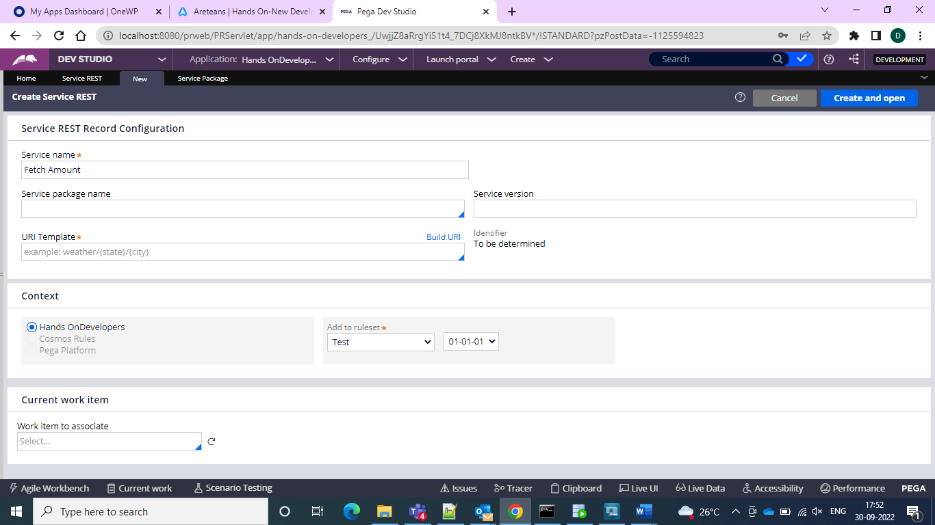

And then create a service package

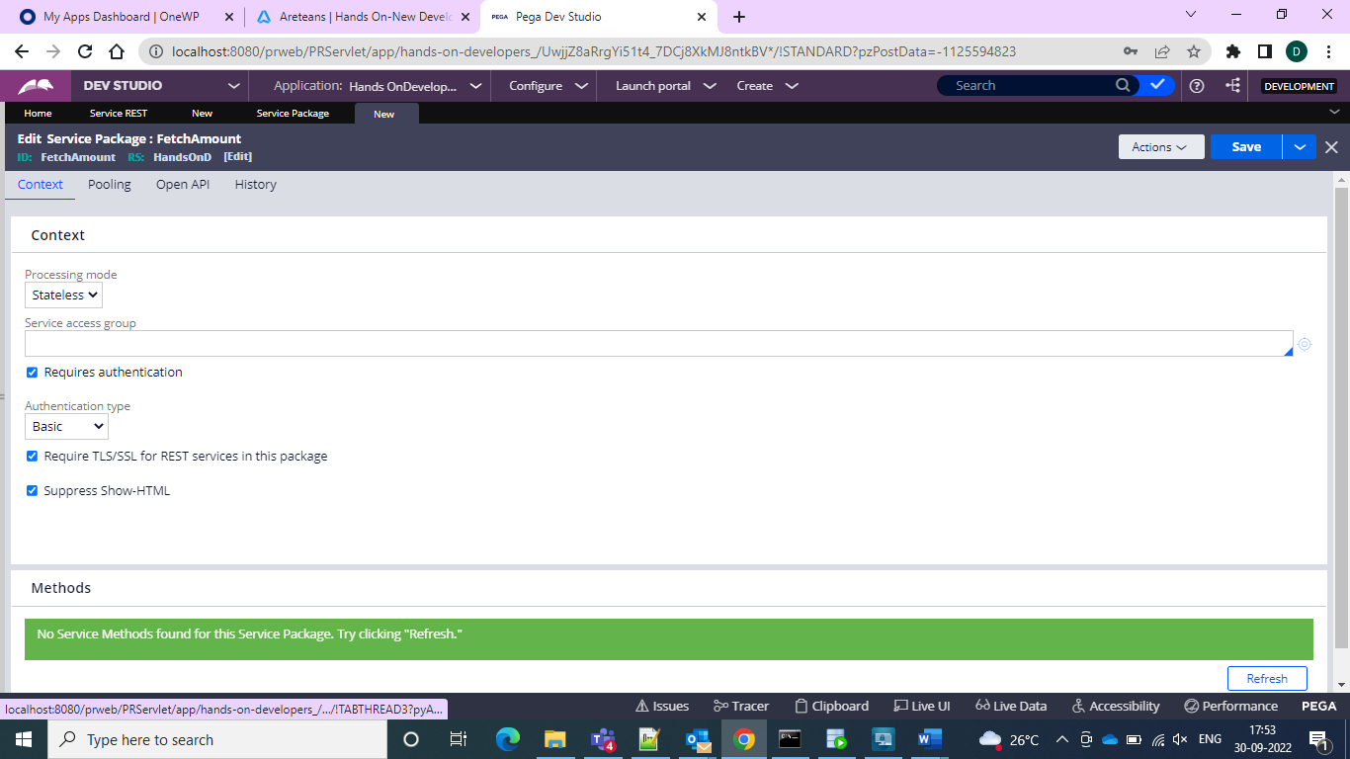

And then add the service package to the rest config and add version as v1 and it will only build the URL and then go for the parameters in the rest and give the param as EMI and account holder.

And now create an activity to fetch and calculate EMI

Give pages and classes

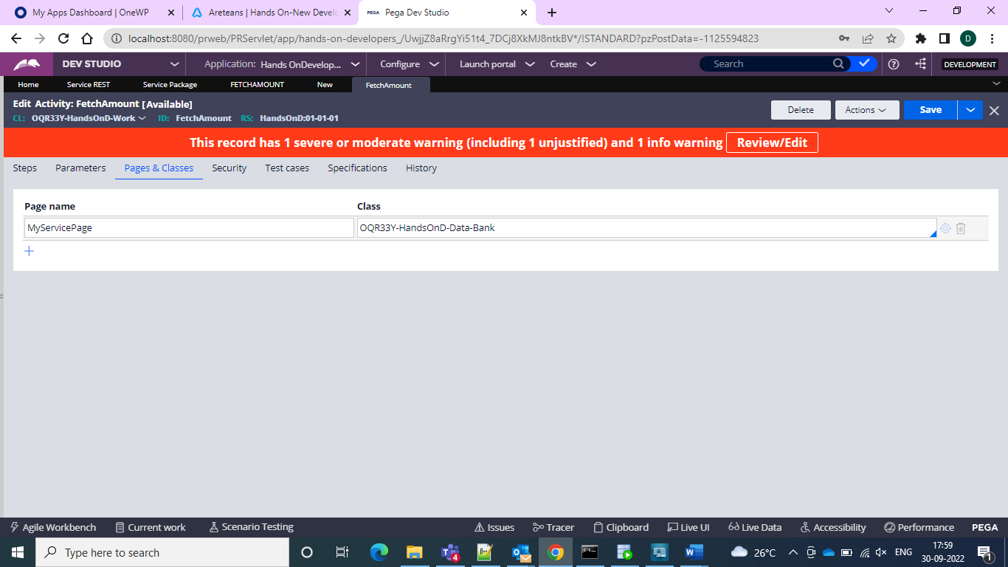

And in the main activity give OBJ-Open and and give the page and give release on commit and add the property values to do the calculation

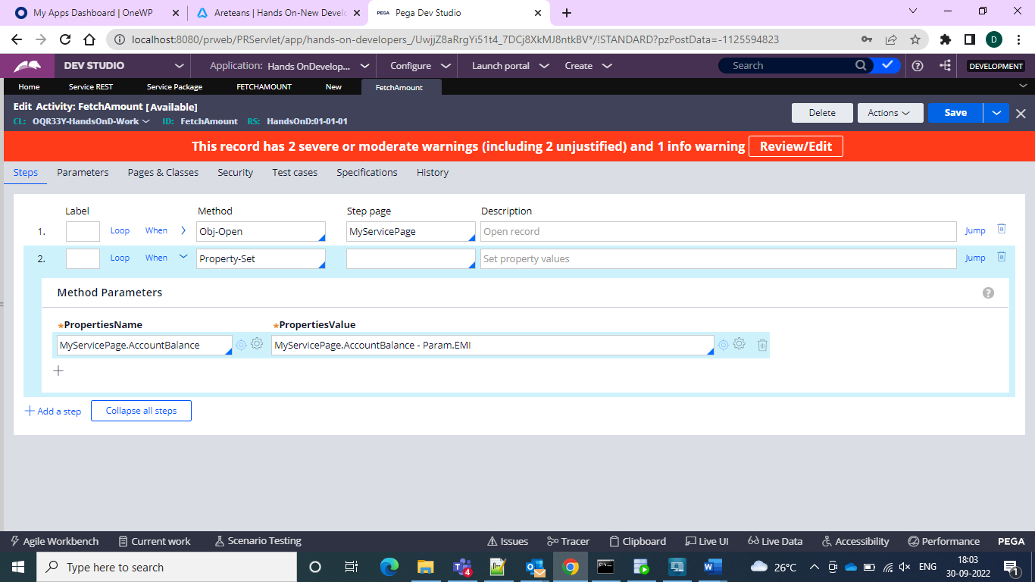

And then in the serviced rest give the GET Message details and now go for another application to show the EMI and amount calculated and in that application create one REST connect and then give the details

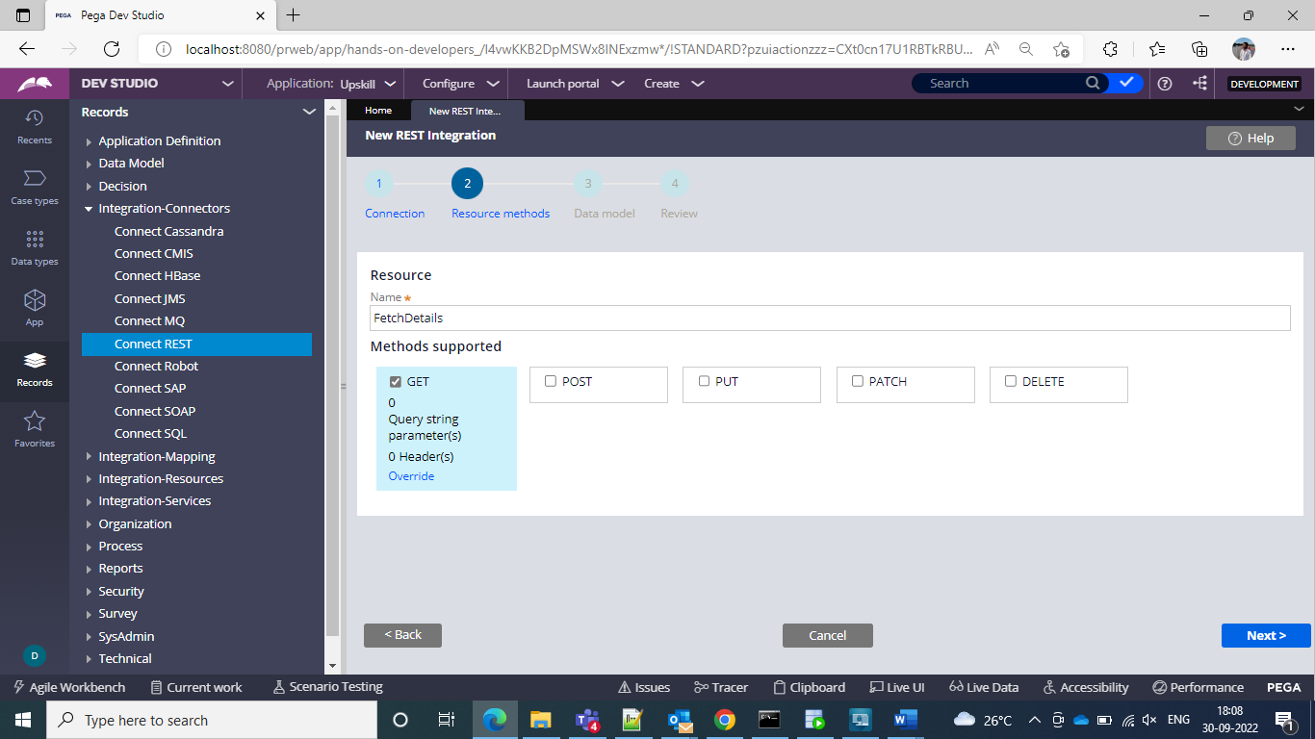

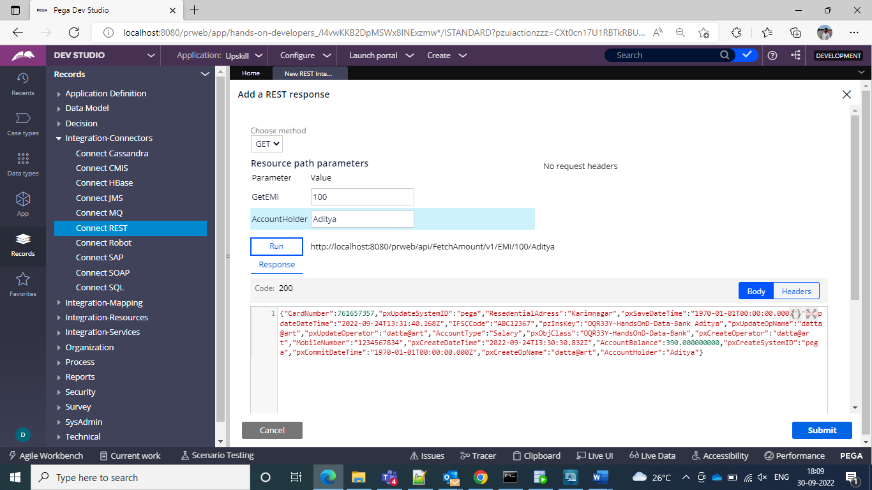

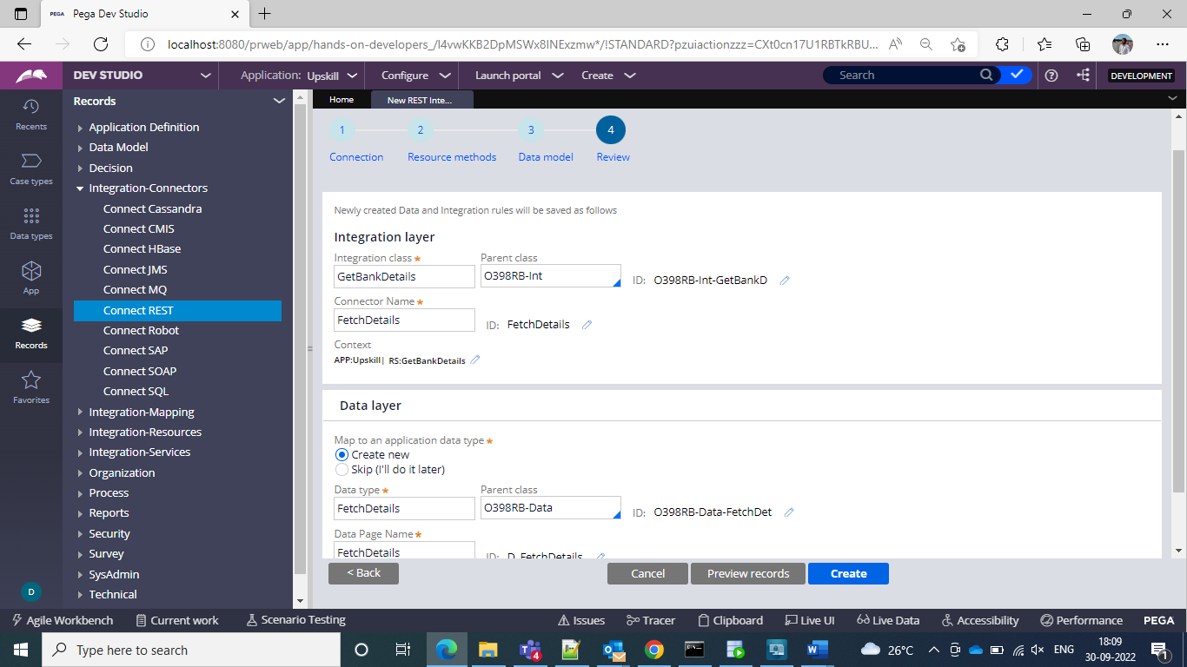

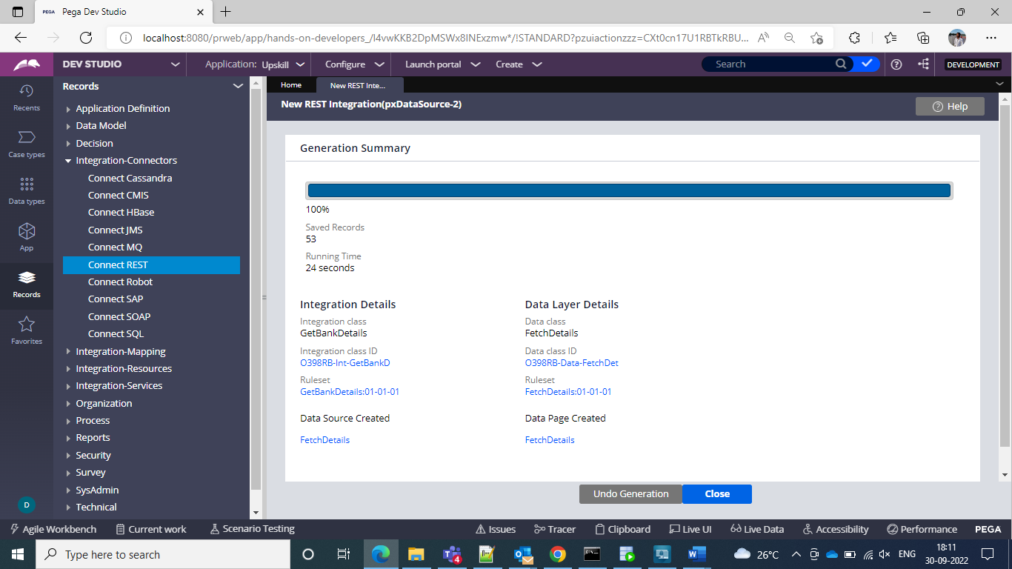

And then we would be obtaining an data page and response and request data transforms

Then create a case type and section

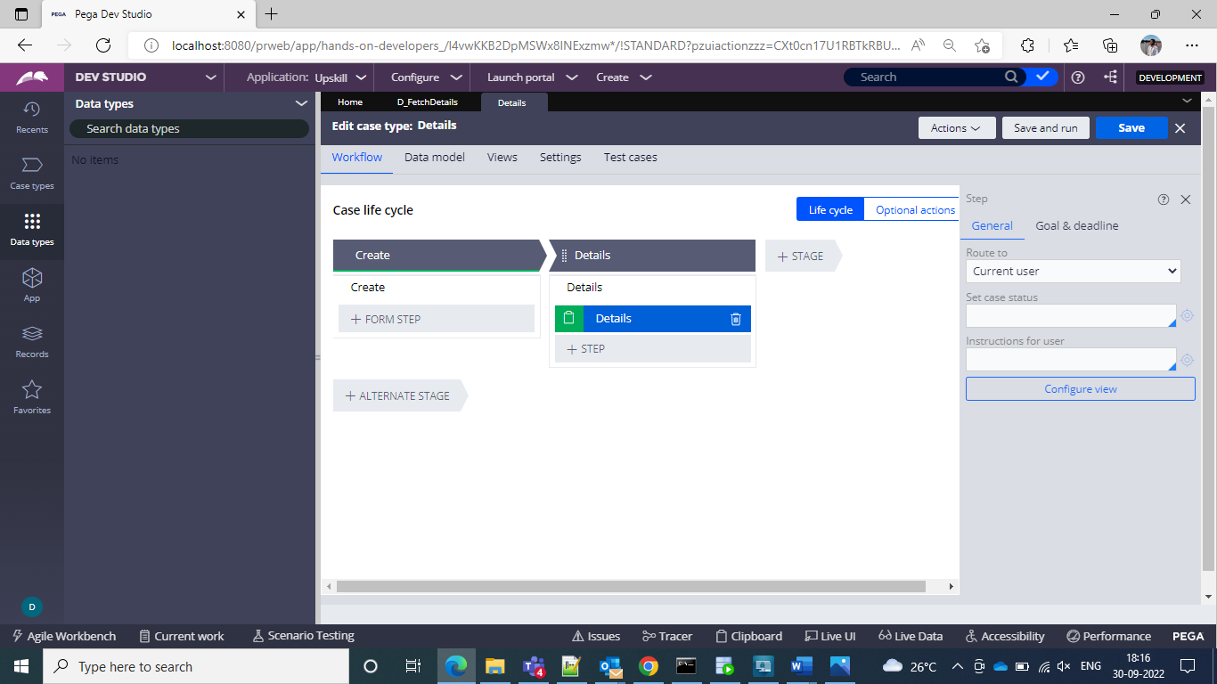

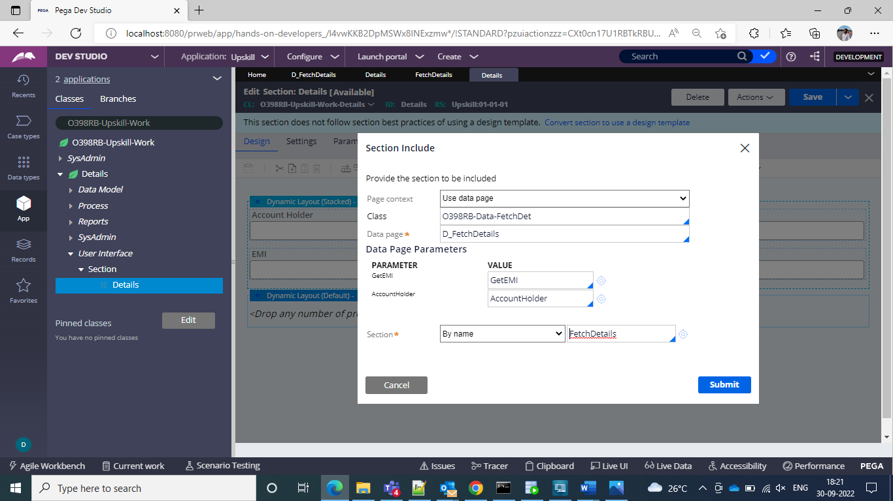

And then pass the parameters in the datapage and give I in the section and pass this activity in the post processing of the flow action

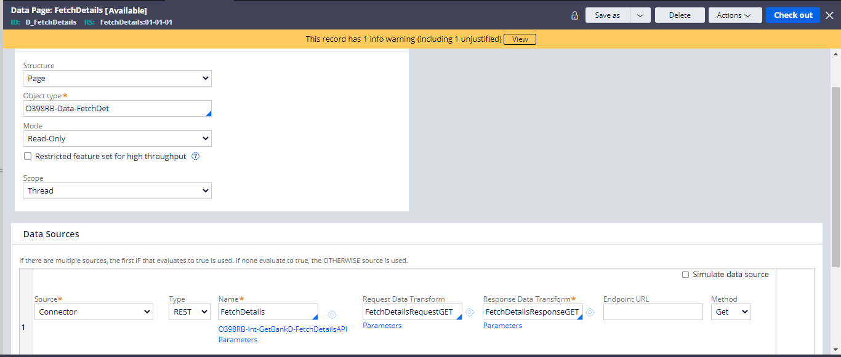

And now can pass and check the details by running the case

